



**“ANALYSIS OF COMMERCIAL ELECTRICITY CONSUMPTION IN INDIAN STATE”**

**“Tirunelveli Dakshina Mara Nadar Sangam College”**

|  |  |
| --- | --- |
| **NM ID** | **NAME** |
| 5132E36FD468A72A2B6432D5F7F213AD | VIDHYA K |

Trainer Name: R UMAMAHESWARI

Master Name: R UMAMAHESWARI

|  |  |
| --- | --- |
|  |  |
|  |  |
|  |  |

**ABSTRACT**

The demand for energy has been increasing over the years in India, which may be the result of its rapid economic growth trajectory. In this context, this study examines the direction of the Granger –causal relationship between electricity consumption and economic growth at the state and sectoral levels in India. In doing so, the panel co integration tests with the structural break, the heterogeneous panel causality test and the panel VAR-Volt-Amps Reactive based impulse response model are employed. The study covers overall economic growth and growth in agricultural and industrial sectors for eighteen major Indian states for the period 1960-1961 to 2014-2015.The results provide evidence in support of a long-term relationship between economic growth and electricity consumption only in the agriculture sector.

**INDEX**

|  |  |  |
| --- | --- | --- |
| **Sr. No.** | **Table of Contents** | **Page No.** |
| 1 | Chapter 1: Introduction | 4 |
| 2 | Chapter 2: Services and Tools Required | 6 |
| 3 | Chapter 3: Project Architecture | 7 |
| 4 | Chapter 4: Modeling and Result | 9 |
| 5 | Conclusion | 18 |
| 6 | Future Scope | 19 |
| 7 | References | 20 |
| 8 | Links | 21 |

**CHAPTER 1**

**INTRODUCTION**

* 1. **Problem Statement**

**India has the sixth highest energy demand in the world accounting 3.5/of commercial energy consumption globally. Oil demand in India is expected to grow by a factor of 2.2 by 2030.The only long- term solution to this problem is switching to renewable sources such as solar, wind, etc. A Process in which intelligent modeling software uses the Power BI to determine the most effective electrical system.**

* 1. proposed Solution

**The proposed solution is to develop a Power BI dashboard that can analyze and visualize real-time problems faced by people in day-to-day life. This dashboard will integrate the trading, mapping, etc. Through Power BI software we not only develop a visual representation of data but also learn about computer and technical skills which are very necessary in executing digital businesses. Power BI is important for organizations because it allows them to make data-driven decisions, gain valuable insights and drive business success. It enables users to consolidate and analyze data from multiple sources, visualize data in interactive ways, and share insights with stakeholders. Promotes collaboration, enhances data exploration, and augments process optimization in various industries and sectors.**

**1.3Feature**

**1. Analysis of commercial electricity: The Dashboard will provide Analysis of commercial electricity Data.**

**2. Renewable Energy: The rise in solar and wind was largely offset by reduced hydropower output.**

**3. Global comparison and Emerging Economies: Developed Economics reported substantial reductions in manufacturing and industrial output, and high inflation.**

* 1. **Advantages**

1. Human Resources Analytics: Power BI can be used to analyze HR data such as employee turnover, performance and training effectiveness.

2. Supply Chain Management: Power BI can integrate data from multiple system to provide end-to-end supply chain visibility.

3. Healthcare Analytics: Power BI has applications in the healthcare industry, where it can help providers analyze patient data, track healthcare outcomes and monitor the effectiveness of treatments.

* 1. **Scope**

India is the world’s third largest energy consuming country, Energy use has doubled. Since 2000, with 80% of demand still being met by coal, oil and solid biomass. As India recovers from a covid- Induced slump in 2020, it is reentering a very dynamic period in its energy development. Over the coming years, millions of Indian households are set to buy new appliances, air conditioning units and vehicles. India will soon become the world’s most populous country. To meet growth in electricity demand over the next twenty years, India will need to add a power system.

**CHAPTER 2**

**SERVICES AND TOOLS REQUIRED**

**2.1 Services Used**

**Data Modeling: Create a data model in Power BI by defining relationships between different tables or data sources. This step helps organize the data for analysis and reporting.**

**Data Visualization:** Design the visual elements of the dashboard using various Power BI visualizations to represent energy consumption data effectively.

**Dashboard Layout:** Arrange the visualization on the dashboard canvas to create an intuitive and user – friendly layout.

**Interactivity:** Add interactive elements to the dashboard, such as slicers or filters, to allow users to explore the data further and customize their views. This enhances the user experience and facilitates data analysis.

**2.2 Tools and Software used**

**Tools**:

* **Power BI**: The main tool for this project is Power BI, which will be used to create interactive dashboards for real-time data visualization.
* **Power Query**: This is a data connection technology that enables you to discover, connect, combine, and refine data across a wide variety of sources.

**Software Requirements**:

* **Power BI Desktop**: This is a Windows application that you can use to create reports and publish them to Power BI.
* **Power BI Service**: This is an online SaaS (Software as a Service) service that you use to publish reports, create new dashboards, and share insights.
* **Power BI Mobile**: This is a mobile application that you can use to access your reports and dashboards on the go.

**CHAPTER 3**

**PROJECT ARCHITECTURE**

**3.1 Architecture**

**USER FRONTEND BACKEND**

|  |  |  |
| --- | --- | --- |
|  | **HTML 5** | **NODEJS 14.0**    **Database** |

Here’s a high-level architecture for the project:

1. **Data Collection**: Real-time customer data is collected from various sources like bank transactions, customer interactions, etc. This could be achieved using services like Azure Event Hubs or AWS Kinesis.
2. **Data Storage**: The collected data is stored in a database for processing. Azure SQL Database or AWS RDS can be used for this purpose.
3. **Data Processing**: The stored data is processed in real-time using services like Azure Stream Analytics or AWS Kinesis Data Analytics.
4. **Machine Learning**: Predictive models are built based on processed data using Azure Machine Learning or AWS Sage Maker. These models can help in predicting customer behavior, detecting fraud, etc.
5. **Data Visualization**: The processed data and the results from the predictive models are visualized in real-time using Power BI. Power BI allows you to create interactive dashboards that can provide valuable insights into the data.
6. **Data Access**: The dashboards created in Power BI can be accessed through Power BI Desktop, Power BI Service (online), and Power BI Mobile.

This architecture provides a comprehensive solution for real-time analysis of bank customers. However, it’s important to note that the specific architecture may vary depending on the bank’s existing infrastructure, specific requirements, and budget. It’s also important to ensure that all tools and services comply with relevant data privacy and security regulations.

**CHAPTER 4**

**MODELING AND RESULT**

**Manage relationship**

The “disp” file will be used as the main connector as it contains most key identifiers (account id, client id and disp id) which can be used to relate the 8 data files together. The “district” file is use to link the client profile geographically with “district id”

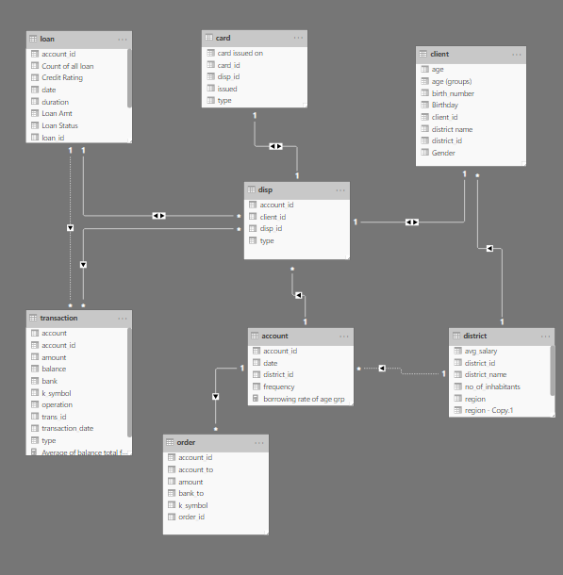

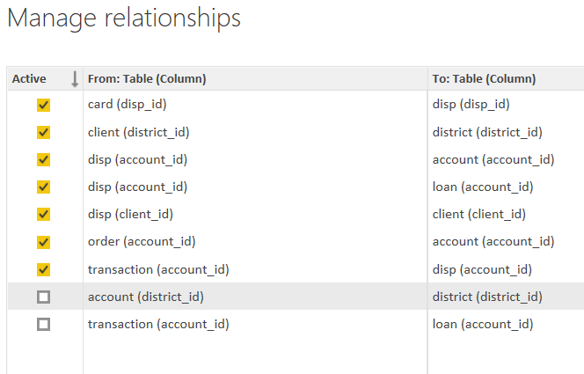

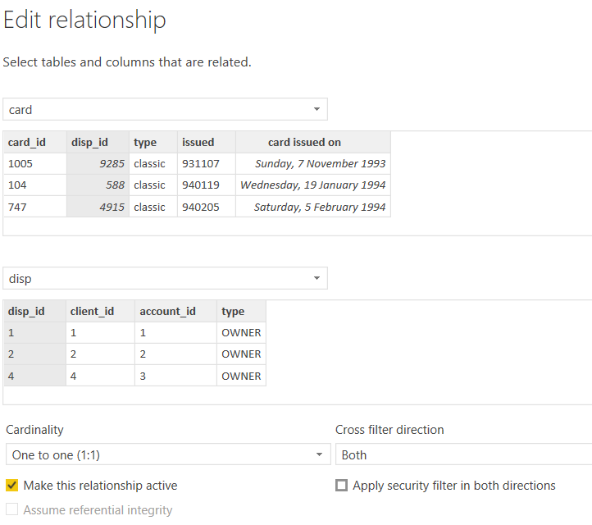

**Modeling for Gender and Age data**

Notice that the Gender and age of the client are missing from the data. These can be formulated from the birth number YYYYMMDD where at months (the 3rd and 4th digits) greater than 50 means that client is a Female. We can create a column for Gender.

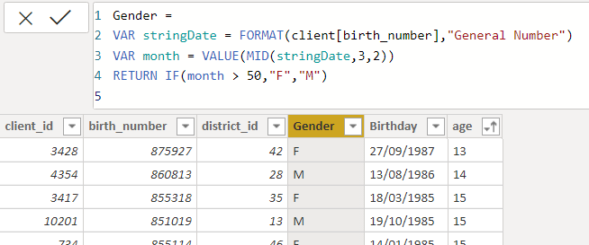

For birthdays, we need to reduce the birth month of the female by 50 and then change the date format to DD/MM/YYYY adding 1900 to the year.

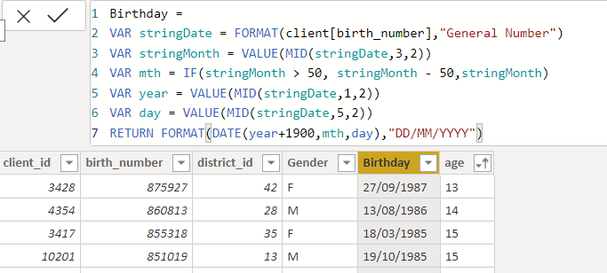

For Age, we shall assume it is the year 1999 as explained previously and use it to minus from the birth year.

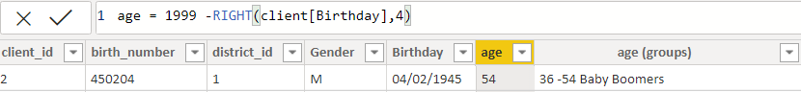

**Replacing values**

Set some fields to English for easy understanding, we replace values to English with the Power Query Editor.

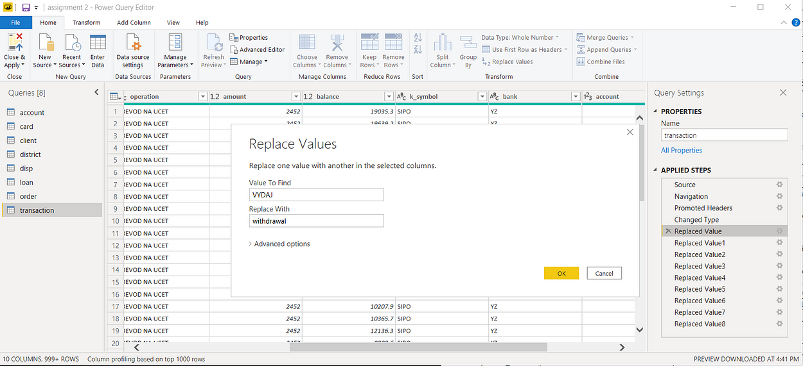



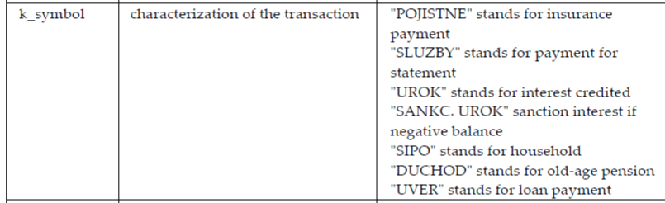

Changing the order of Region name at Power Query

Duplicate the “district /region” then split the column using space as delimiter.

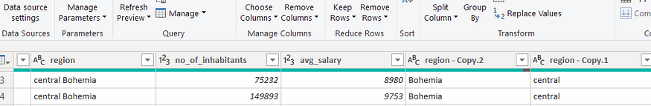

Then merge columns by Region and direction. Refer to applied steps for details.

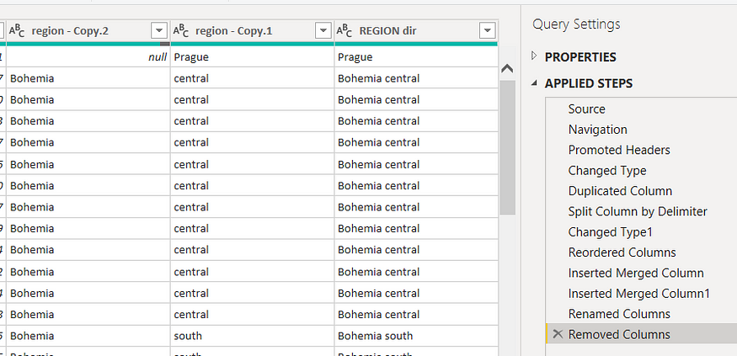

**Grouping of age by ranges**

As the customers’ age ranges from 12 to 88, we shall group them into different generation age ranges for easier profiling, we will group the ages into 5 groups.

The Gen Y are youths,

Gen X are young working adults, some starting their families

Baby Boomers are working adults with families.

The silent Generations some are working and retired, living on pensions.

The greatest Generation, retired elderly living on pensions.

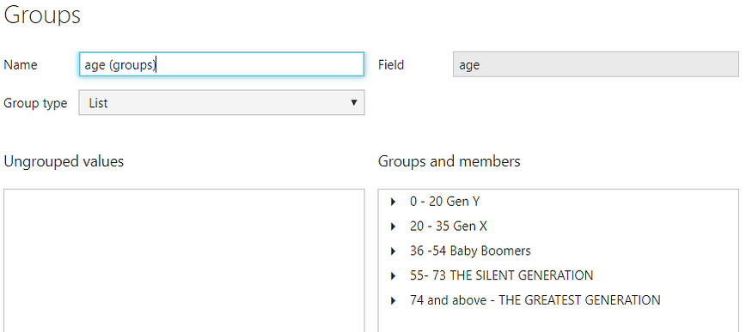

**Credit Rating and Loan Status**

As the Loan status uses A, B, C, and D which are not reader friendly. We can add a column to represent what it stands for, we also simplify the classification of those with late or default on payment as bad credit, refer to the table below for details on the new columns added.

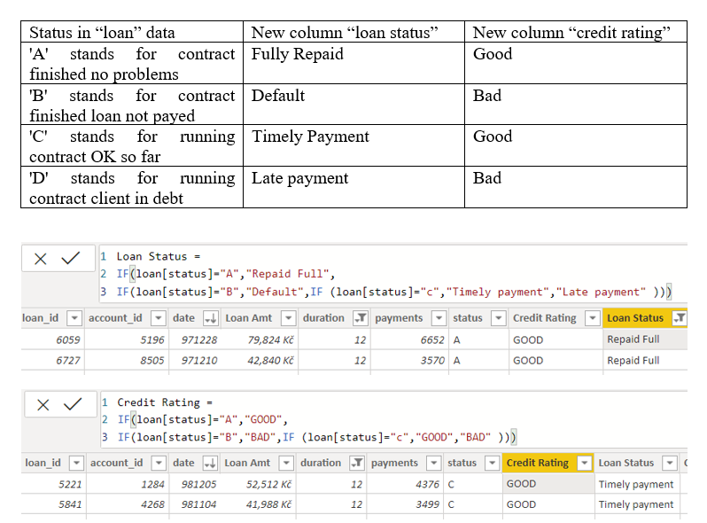

Values such as “account Id” have also been set as Text.

And District names have been categorized as places to be used for the map to show the sum of the inhabitants in each region.

**Dashboard**

**CONCLUSION**

**Projections for the demand for electricity in India are not just numbers on a graph; they represent the nation’s journey towards a brighter, sustainable future. As India strives for economic growth, industrial progress, and improved living standards, the power sector’s ability to accurately project and meet electricity demand becomes a critical factor in shaping the nation’s energy destiny.**

**FUTURE SCOPE**

The future scope of this project is vast. With the advent of advanced analytics and machine learning, Power BI can be leveraged to predict future trends based on historical data. Integrating these predictive analytics into the project could enable the bank to anticipate customer needs and proactively offer solutions. Furthermore, Power BI’s capability to integrate with various data sources opens up the possibility of incorporating more diverse datasets for a more holistic view of customers. As data privacy and security become increasingly important, future iterations of this project should focus on implementing robust data governance strategies. This would ensure the secure handling of sensitive customer data while complying with data protection regulations. Additionally, the project could explore the integration of real-time data streams to provide even more timely and relevant insights. This could potentially transform the way banks interact with their customers, leading to improved customer satisfaction and loyalty.

**REFERENCES**

<https://medium.com/analytics-vidhya/analysis-of-bank-customers-using-dashboard-in-power-bi-a366f2b3e563>